ESP Test Project proposal

Jari Koskinen, FIN, Tietomyrsky Oy

WorldSkills Training Board

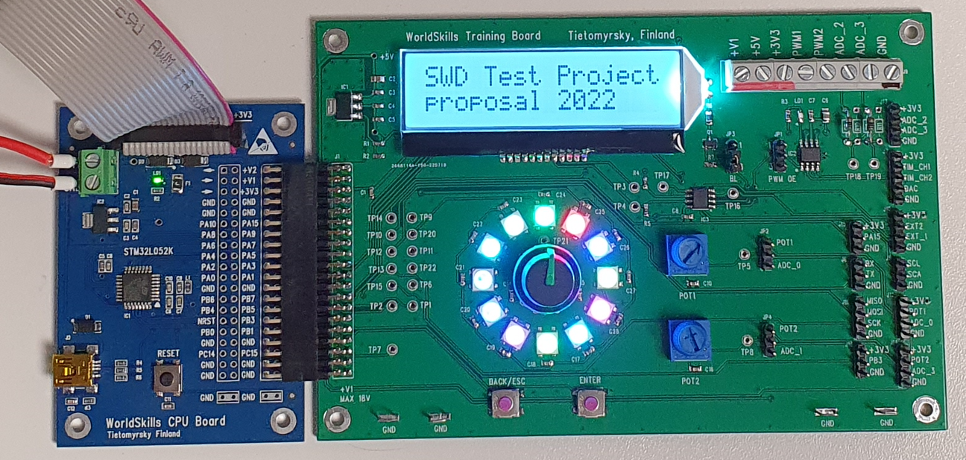

This board is brand new and designed for general use as much as possible.

Boards arrived from the PCB manufacturer on 7/28/2022 and the first board has only been assembled on same evening. The first test program was made next day. Therefore, the documentation is not yet completely ready. If this proposal is chosen, I will publish an example of a project with the necessary functions for applying the components on the board.

**Features**

**Application** in this case means the **Test Project** produced by an external designer. The board has screw terminals that can be used to connect the 3.3 V- 18 V tolerant part of applications. Pin header are suitable for different sensors or ready-made additional boards.



It is possible to connect various sensors or other application boards with jumper wires.

**Schematic details**

**Connections**

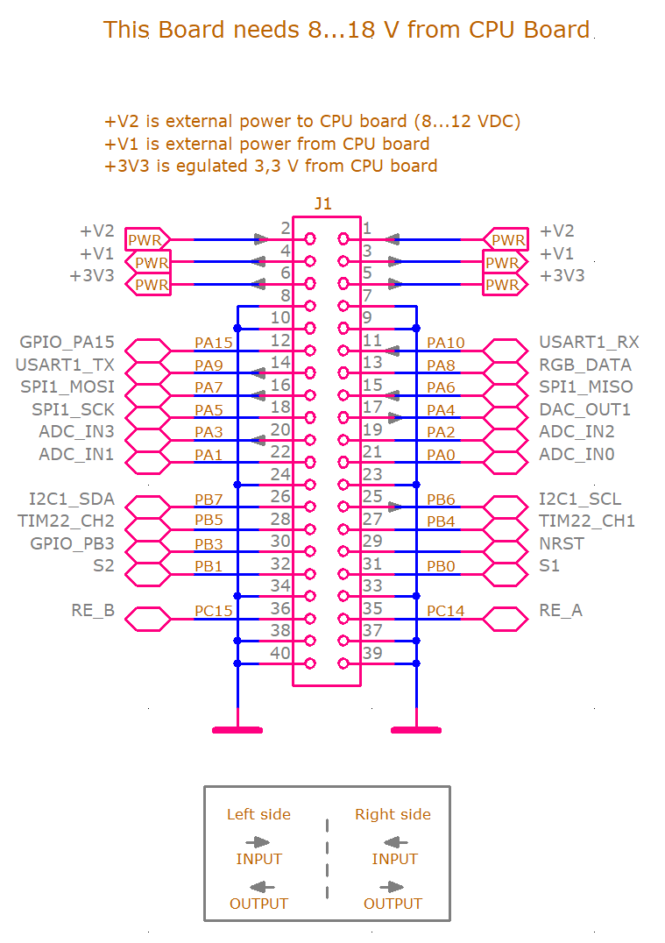

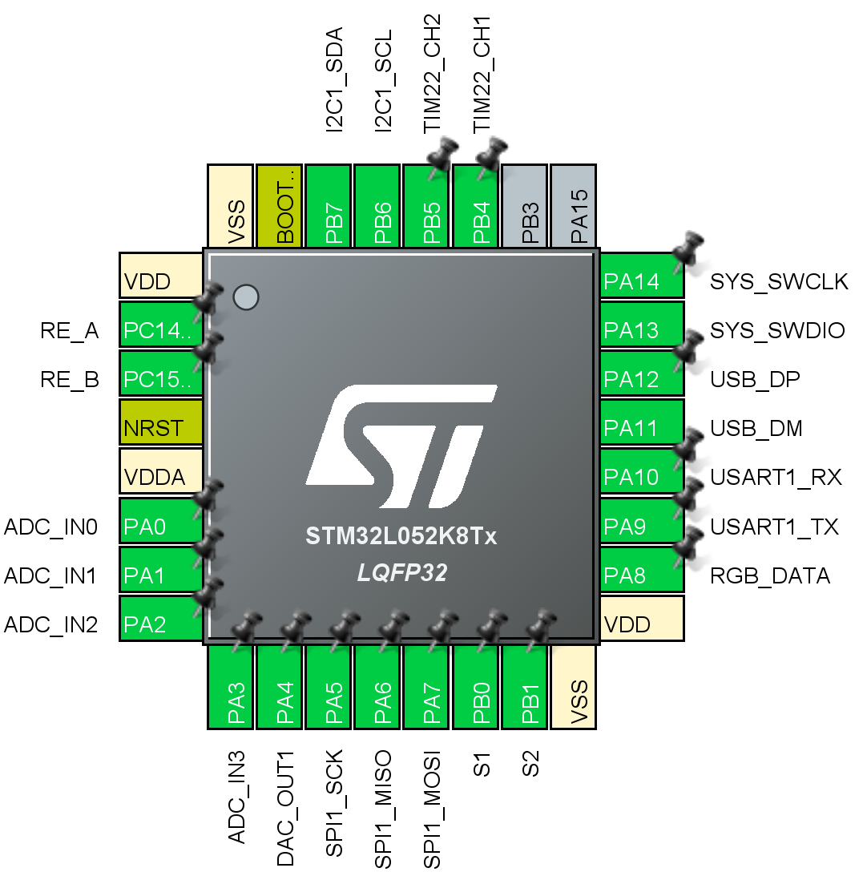

**LCD Display**

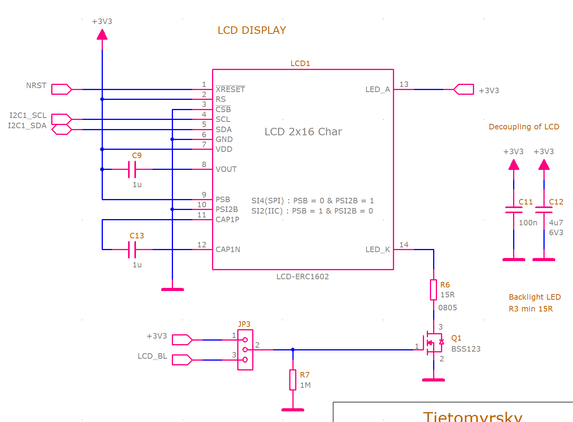

LCD Display is connected to I2C bus.

Back light can be controlled with LCD_BL signal (JP3 1-2) or always ON (JP3 2-3) or OFF (no jumper).

All basic functions for LCD have already been prepared.

**Buffered outputs**

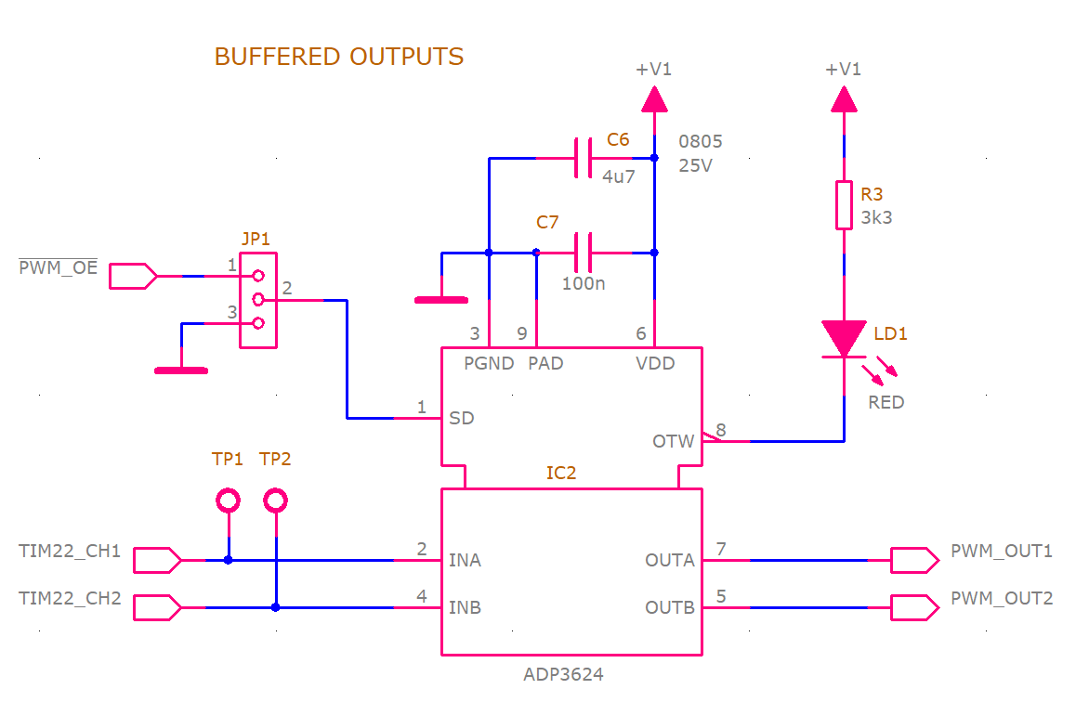

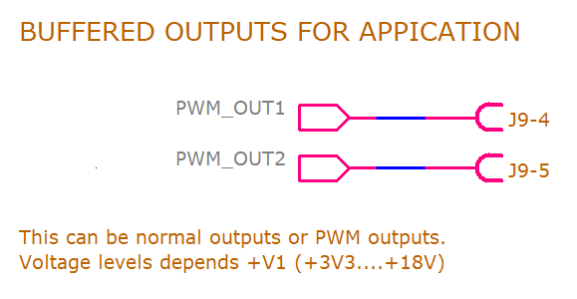 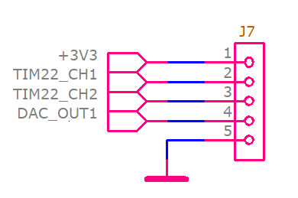

Buffered outputs are connected to TIM22 outputs CH1 and CH2. Same signals are connected also to pin header J7. Both connectors cannot be used for different purposes at the same time.

Buffered outputs can enabled/disabled with \PWM_OE signal (JP1 1-2) or always enabled (JP1 2-3) or disabled (no jumper).

ADP3624 is overtemperature protected and LD1 shows overheating.

**IO Expander**

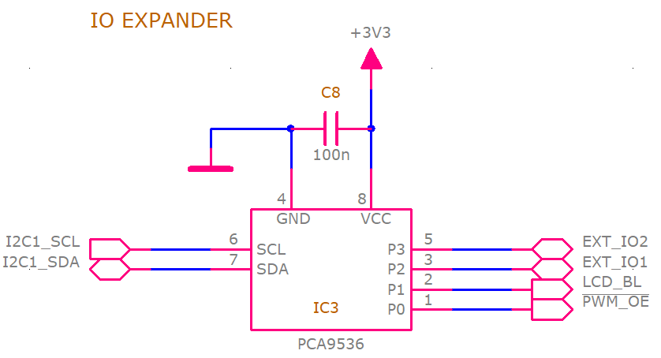

IO Expander is also connected to I2C bus. This control LCD backlight and output enable of buffered outputs. It also has two external GPIOs (I2C controlled).

**Rotary Encoder and buttons**

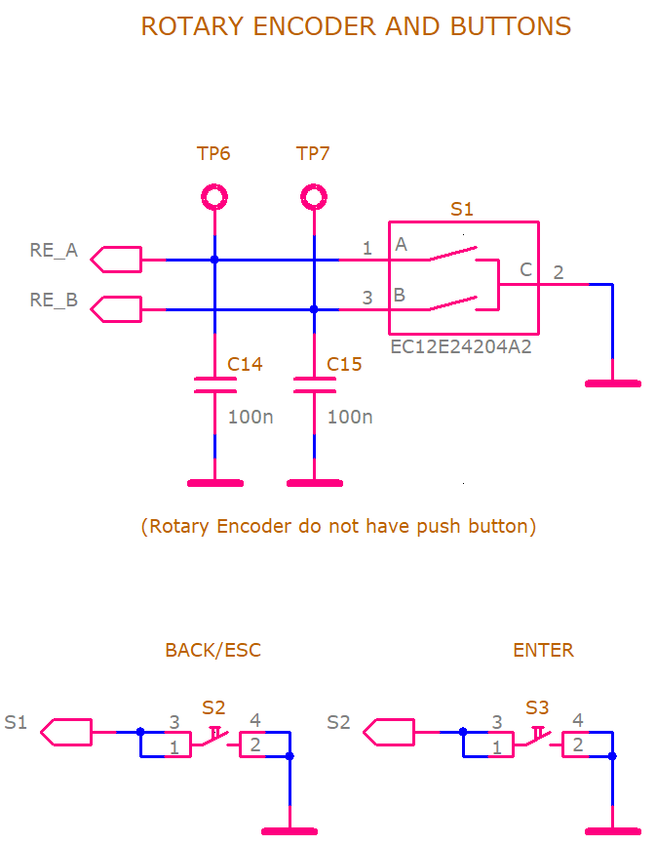

Rotary encoder has been connected two inputs with internal pullups. One of the RE_A or RE_B signals is good to be an interrupted input.

Because rotary encoder does not have integrated bush button there are two buttons to select some function or escape it.

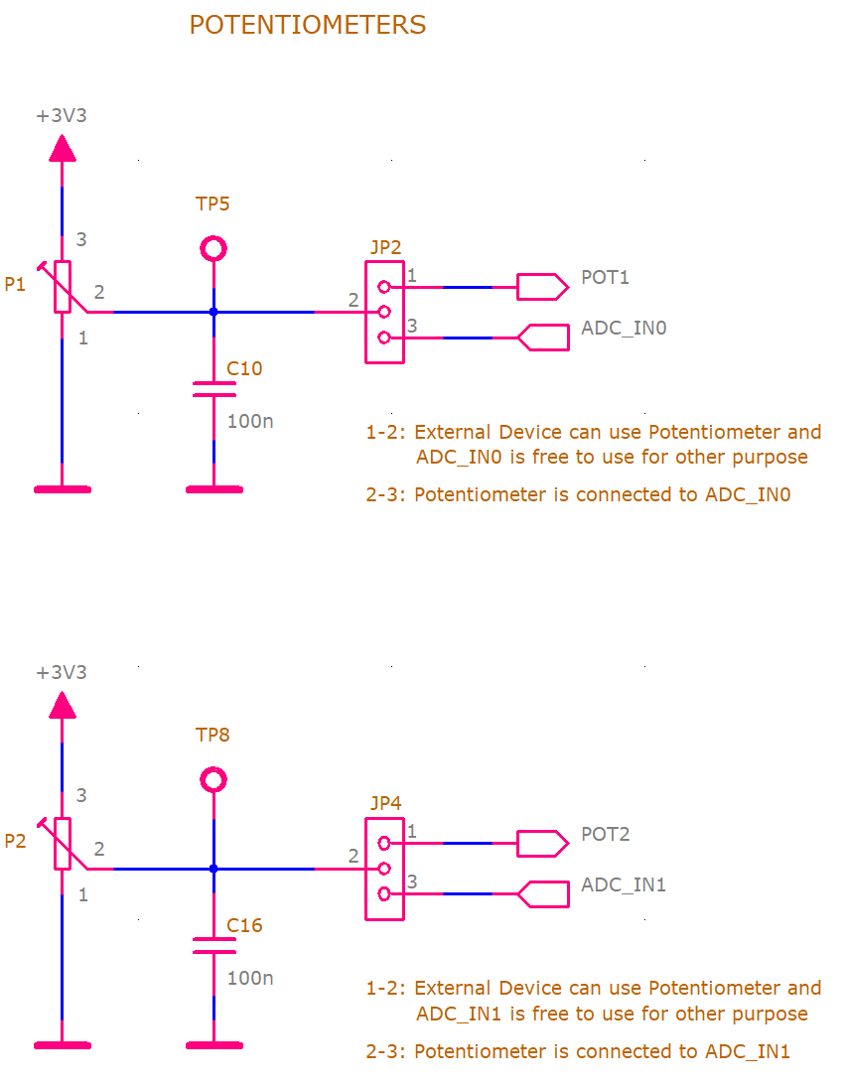**Potentiometers**

Potentiometers can be connected to ADC0 and ADC1 inputs (JP2, JP4 2-3) or they can be connected to external application (JP2, JP4 1-2). If potentiometers are not connected to ADC inputs ADC input can be used other purposes.

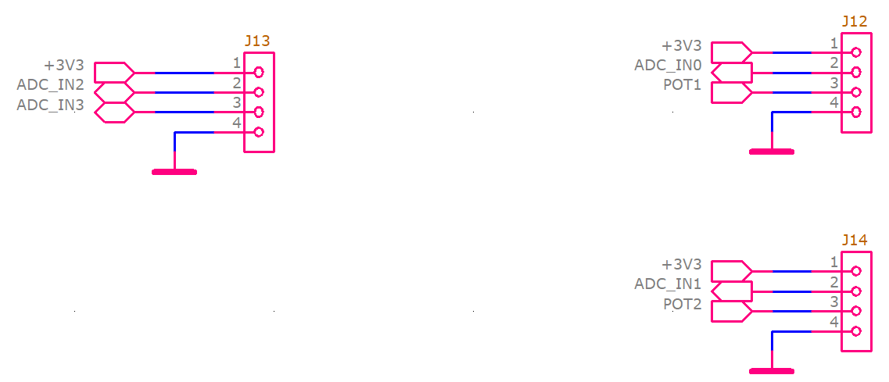

**Intelligent RGB leds**

There are 12 famous intelligent WS2812B RGB leds which are individually programmable. This need code optimization for speed (-Ofast). Programming the LEDs is also very time critical and therefore it must be done according to the code below.

*The final code needed to control the LEDs is still under construction and will be published later if this board is used in the competition.*

**Connectors and voltage dividers**

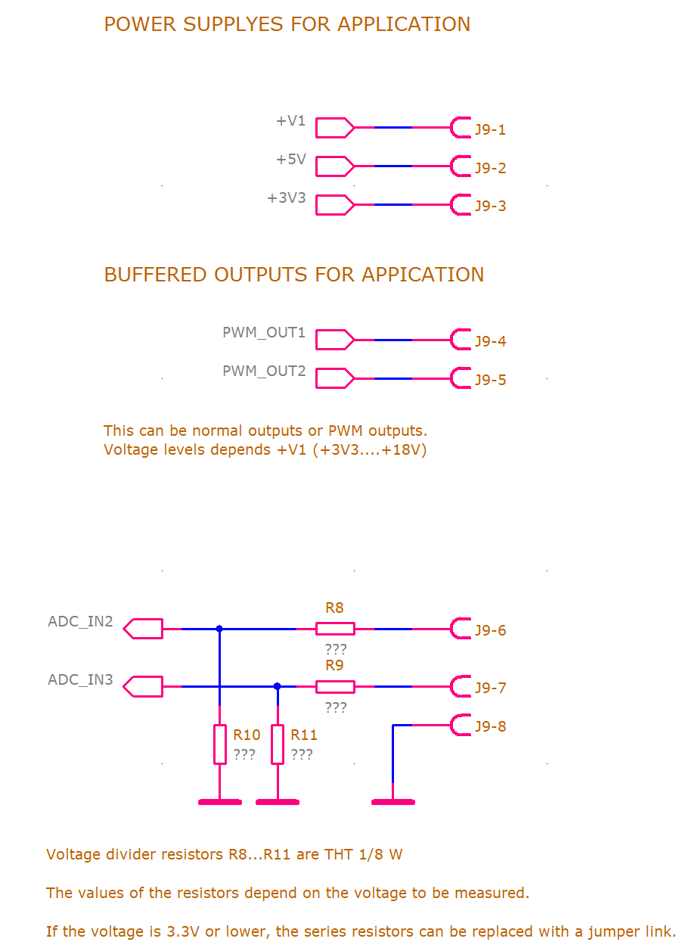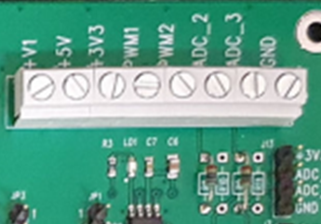

There are two ADC inputs (ADC2 and ADC3) which have voltage dividers if input voltage is higher than 3.3 V. The resistance values of these resistors depend on the input voltage. They will be installed later according to the application requirement.

**PCB**

